App name: Maps - Navigation & Transit

- Description
Going somewhere? Go with Maps, the official app you can rely on for real-time GPS navigation, traffic, transit, and details about millions of places, such as reviews and popular times.
Get there faster with real-time updates
Beat traffic with real-time navigation, ETAs and traffic conditions
Catch your bus, train, or ride-share with real-time transit info
Save time with automatic re-routing based on live traffic, road closures and traffic incidents
Navigation with lane guidance so you don t miss a turn or exit
Find pit stops along your route like gas stations and coffee spots
Discover places and explore like a local
Find top-rated restaurants and local businesses, wherever you are
Decide on the best places to go with reviews, ratings, and pictures of foods and interiors
Plan your visit and see menus, make reservations, and find when places are typically busiest
Help others discover the best places by sharing reviews, photos and more
Save places you want to or often visit, and quickly find them later from any computer or device
Experience the Google Maps difference
Offline maps to search, get directions and use navigation without an internet connection
Street View and indoor imagery for restaurants, shops, museums and more
Indoor maps to quickly find your way inside big places like airports, malls and stadiums
Comprehensive, accurate maps in 220 countries and territories
Transit schedules and maps for over 15,000 cities
Detailed business information on over 100 million places
* Some features not available in all countries

- Goal Model
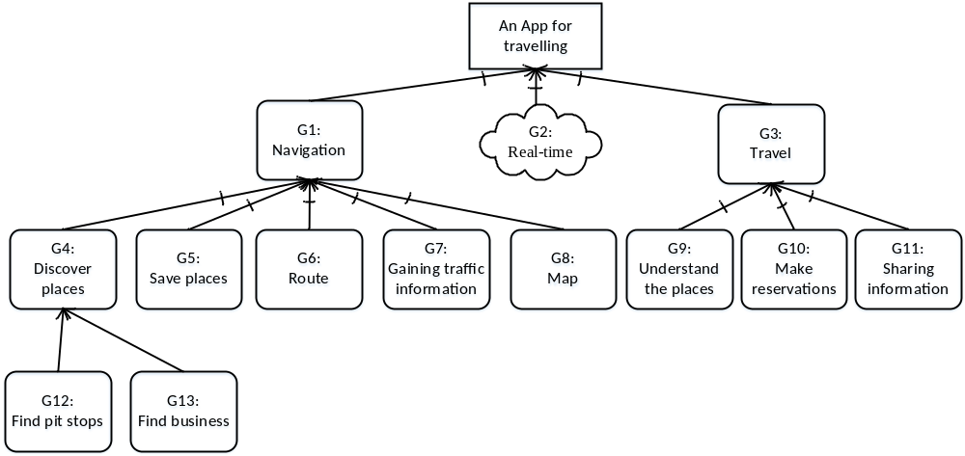

- The description of each goal

ID | Des | Type
G1 | Navigating, guiding persons to their destinations | Hard goal
G2 | Real-time, quickly and timely | Soft goal
G3 | Travelling, supporting people to schedule their journey | Hard goal
G4 | Discover places and explore like a local by inputting keywords | Hard goal
G5 | Save places you want to or often visit, and quickly find them later from any computer or device | Hard goal
G6 | Routing the road | Hard goal
G7 | Gaining traffic information, road closures and traffic incidents and transit schedules. | Hard goal
G8 | Comprehensive, accurate maps in 220 countries and territories | Hard goal
G9 | Understanding places with reviews, ratings, and pictures of foods and interiors | Hard goal
G10 | Make reservations | Hard goal
G11 | Sharing information to help others by sharing reviews, photos | Hard goal
G12 | Find pit stops along your route like gas stations and coffee spots | Hard goal
G13 | Find business, including restaurants, shops, museums, along your route. | Hard goal

